Contents

Statement of originality 2

Access Information 2

Description 2

Main Page (Periodic Table of Elements/Find a Part) 2

Find a Certification 3

Create Standard 3

Bugs and other issues 4

Special Features 4

Schema 4

Data Model 4

Application Code 6

Screen Shots 6

Main Page 6

Single element search with default filters 7

Search for an alloy with default filters 8

Search for an alloy with thickness and type filters modified 9

Search for an Infinite (there are only a few of these in the database currently) 10

Selecting standards for certification and changing the acting technician 11

Certifying selected standards 11

Searching by part number 12

Creating a new standard 12

Standards entered and entering an invalid thickness 13

Viewing all certifications 13

View all certifications for a specific part number 14

User modifies a GET variable or some other kind of error occurs 14

# Statement of originality

I hereby certify that this project was prepared especially for this course, and that this or a similar version has not been submitted to any other course.

# Access Information

There is no special information required to access the application. The main page is located here:

<http://cscie60.dce.harvard.edu/~ilebwohl/final_project/periodicTable.cfm>

# Description

The goal of this project is to create a database application for a company that makes and measures standards of measurement. The database is designed to keep track of the product catalog, current inventory, and certifications of measurement. The database also the company to log newly manufactured standards as well as certify their thickness.

This application is intended to act as an updated version of the database currently in use (a single-­user Lotus Approach database whose structure was last updated in 2003). This application provides laboratory technicians the ability to accurately check the inventory for a given product, something that is currently done using a single-­table Excel spreadsheet. This application also keeps track of available products and provides information about them, including their composition and specific densities. When logging newly manufactured standards, the database provides both front-end and back-end validation to ensure that it is within the 15% tolerance for a standard to be certified. Finally, this application keeps track of standards that have been certified and displays all of the standards associated with a given certification.

Please note that, while I modified the data model (from the original project proposal) to allow for the tracking and certification of standard *composition* as well as thickness, designing and implementing the front-end portion fell outside the scope of the project.

The following is a list of the pages in the application, as well as the form(s) and report(s) that are available on each:

## Main Page (Periodic Table of Elements/Find a Part)

* Reports
  + - Displays all of the elements in existence (except for the lanthanide and actinide groups, as they are not relevant to the company and posed a layout challenge that was not worth tackling)
    - Indicates which elements are part of at least one product sold by the company (highlighted in green)
    - Displays all of the products that consist solely of the list of elements chosen (that is, if the user chooses two elements, the application will only show products that consist of an alloy of those two elements) and that meet all other requirements specified by the other filters on the page
    - Displays the products that have the complete or partial part number entered in the part number field
* Forms
  + - The user can select one or more elements from the table. These will be submitted to a query that will return products that consists of the chosen single element or multi-element alloy.
    - The user can apply filters on product type and product thickness (as a range). The thickness filter is prepared to filter for Infinite standards[1]. These filters affect what is displayed once the user selects one or more elements.
    - The user can select one or more products for which they would like to certify standards that have already been manufactured. When doing so, they can select any technician in the company to be the acting technician for this action.
    - The user can create a new standard for any given product by clicking on the “Create New” button next to that product in the table.

## Find a Certification

* Reports
  + - Displays all certifications that exist within the company (ordered by date and limited to a maximum of 5000 for the sake of performance).
      * This report displays in pages, as otherwise the results would be unwieldy and the table sort would crash the user’s browser (as it is done in Javascript)
      * Ideally, I would have done a new AJAX call for each page rather than loading the whole resultset before even displaying the page, but I did not implement that feature. The page currently takes a long time to load.
    - Displays all standards associated with a given certification
* Forms
  + - None

## Create Standard

* Reports
  + - Displays the information associated with the product the user chose
      * This can be either the product for which they clicked “Create New” or the product whose part number they entered in the text box on the page
    - Display information relating to the standards the user creates as they create them (including the generated serial number)
* Forms
  + - The user can change the product for which they are entering new standards using the text box on the page
    - The user can enter a thickness for the standard
      * This thickness is validated on both the front-end and the back-end to ensure that it is within an acceptable range of the target value for the product

# Bugs and other issues

* The “View Certifications” page loads very slowly. This is because the entire query resultset is loaded before the page displays. The fix for this would be to make a new AJAX call every time the user changes the page of the report they are viewing. The paging plugin I used supports this functionality.
* The elements on the periodic table page are not square or really even a uniform size/shape. The fix for this would be to move all other elements outside of the table in which the report displays (currently, other reports display *inside* the main report table, which is just bad practice)
* Changing the part number by which you are searching on the main page does not always trigger the report to run, or does so after some time. I think this might be because the ‘Change’ event is not firing until the user moves their focus from the search box. The fix is probably to add ‘Blur’ to the list of events on which the handler fires.
* A couple of the triggers seem not to work as expected, specifically the triggers to manage the stock listed for a given product in the tbPart table. The fix is likely to remove that field from the table and simply calculate the stock any time it is needed.

# Special Features

Implemented a simple “search by product number” feature on the main page. I also implemented a multi-input query that allows one or many filters to be applied in order to display the desired results. The results are displayed dynamically and in real time as the user changes filter settings. This is also on the main page of the application.

# Schema

See included file.

# Data Model

See next page.

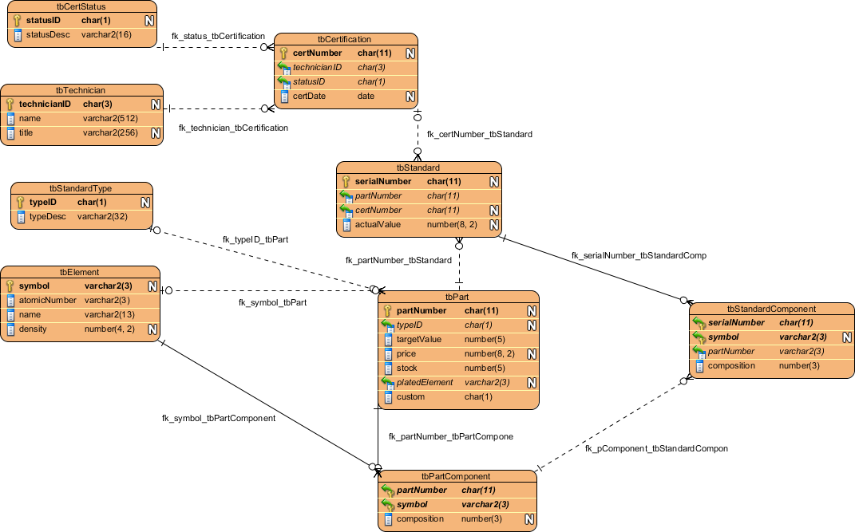

# Application Code

See included files.

# Screen Shots

### Main Page

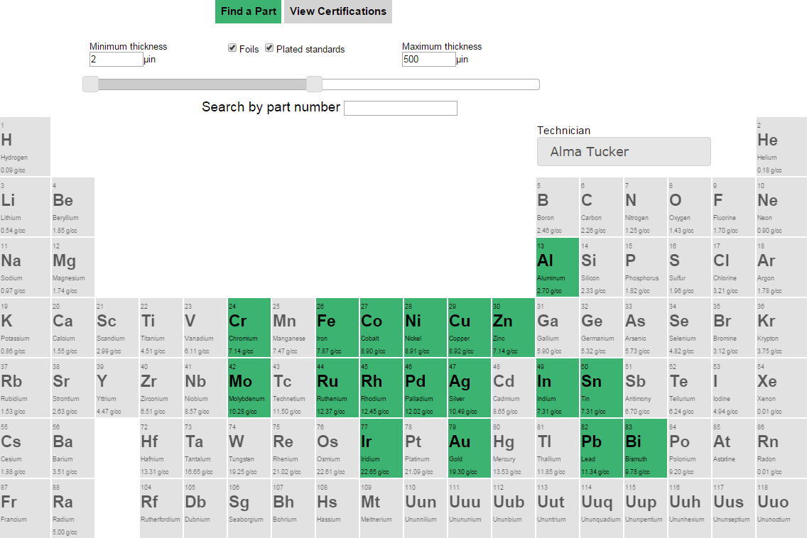

### Single element search with default filters

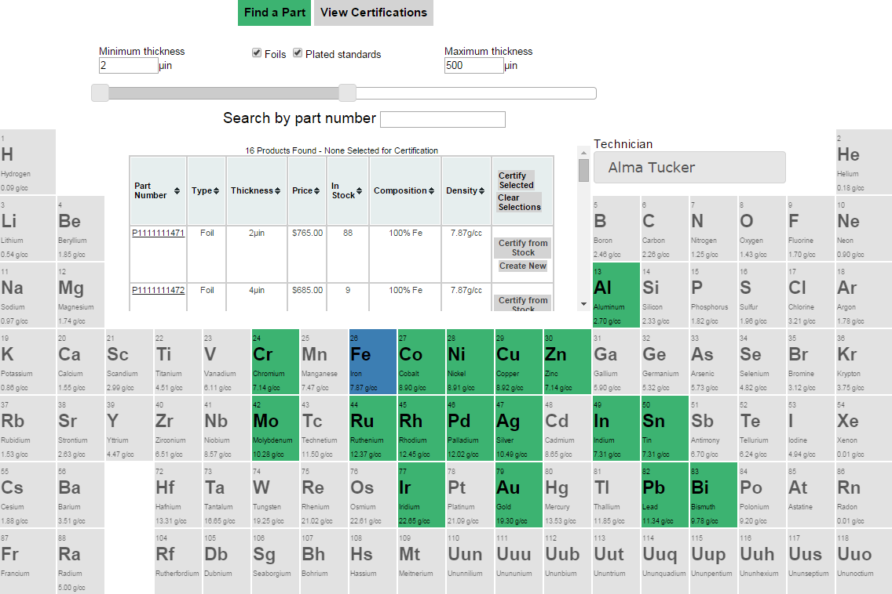

### Search for an alloy with default filters

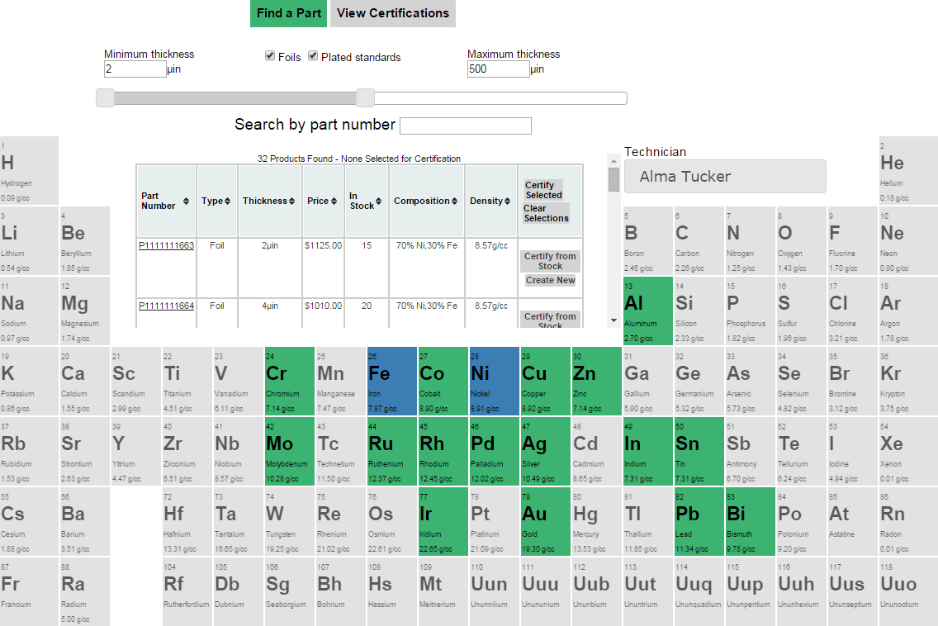

### Search for an alloy with thickness and type filters modified

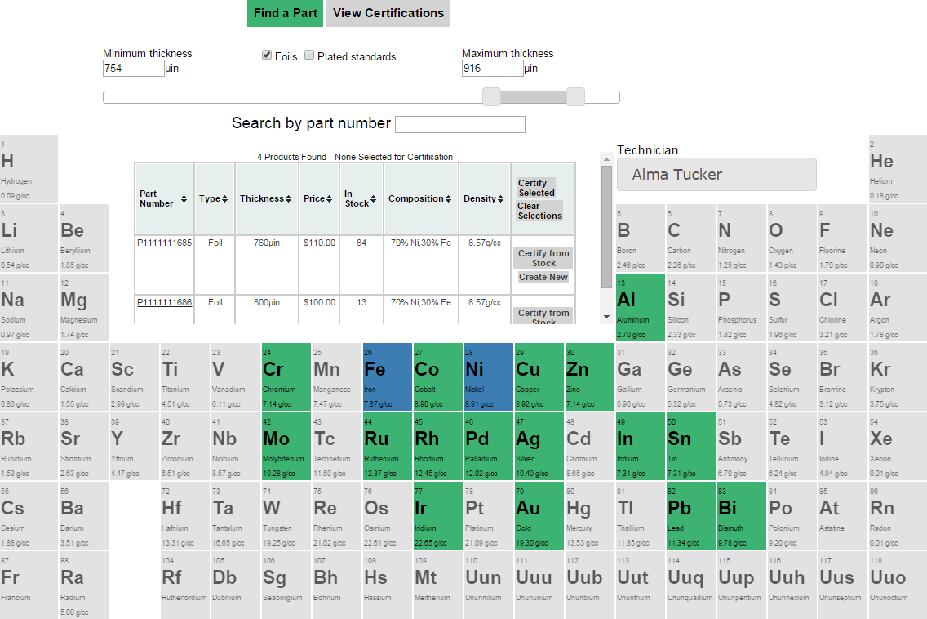

### Search for an Infinite (there are only a few of these in the database currently)

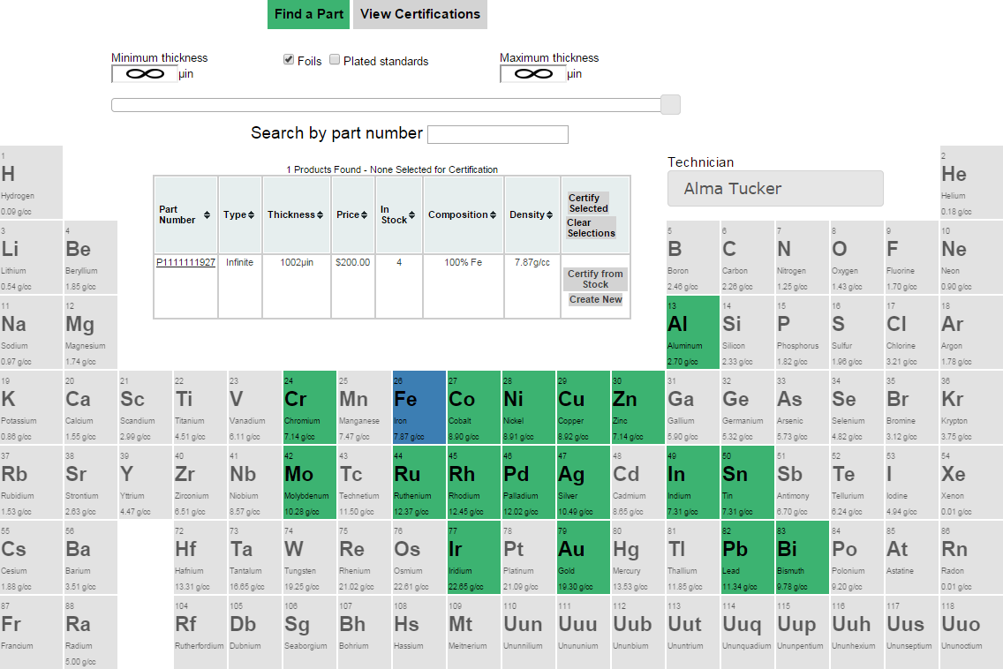

### Selecting standards for certification and changing the acting technician

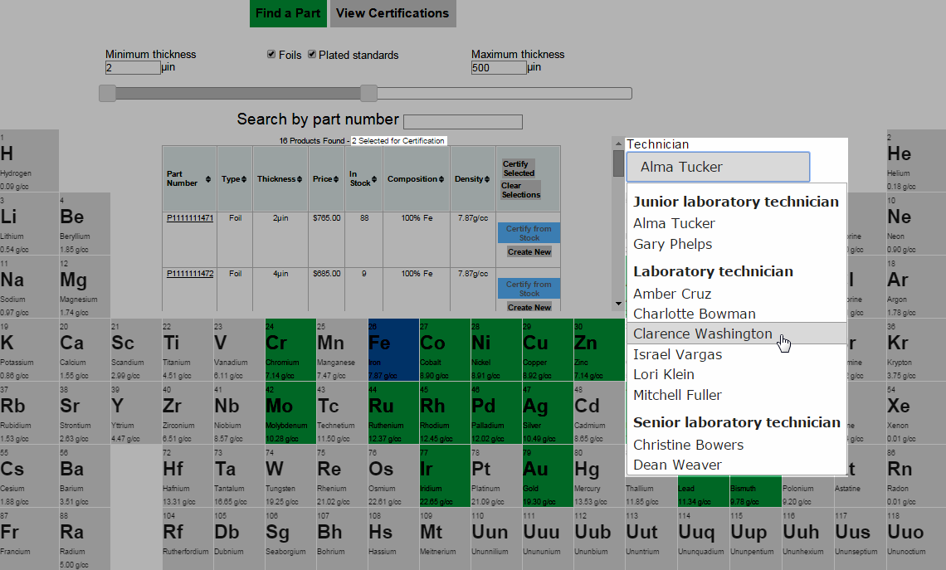

### Certifying selected standards

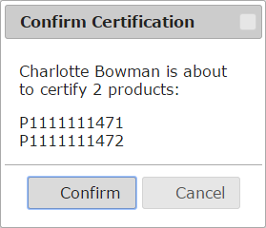

### Searching by part number

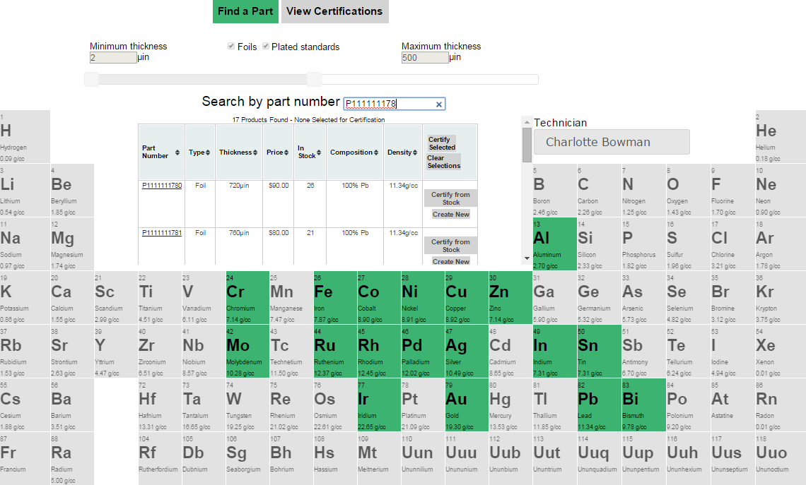

### Creating a new standard

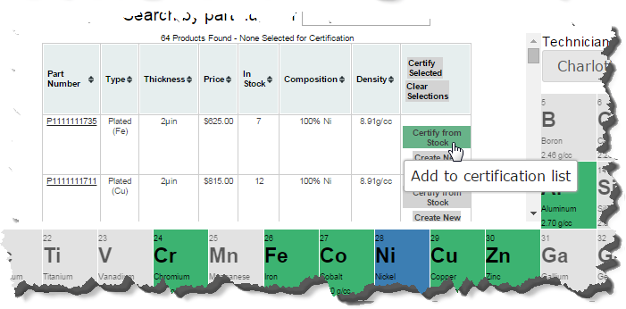

### Standards entered and entering an invalid thickness

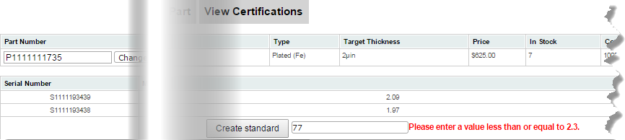

### Viewing all certifications

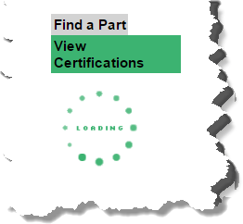

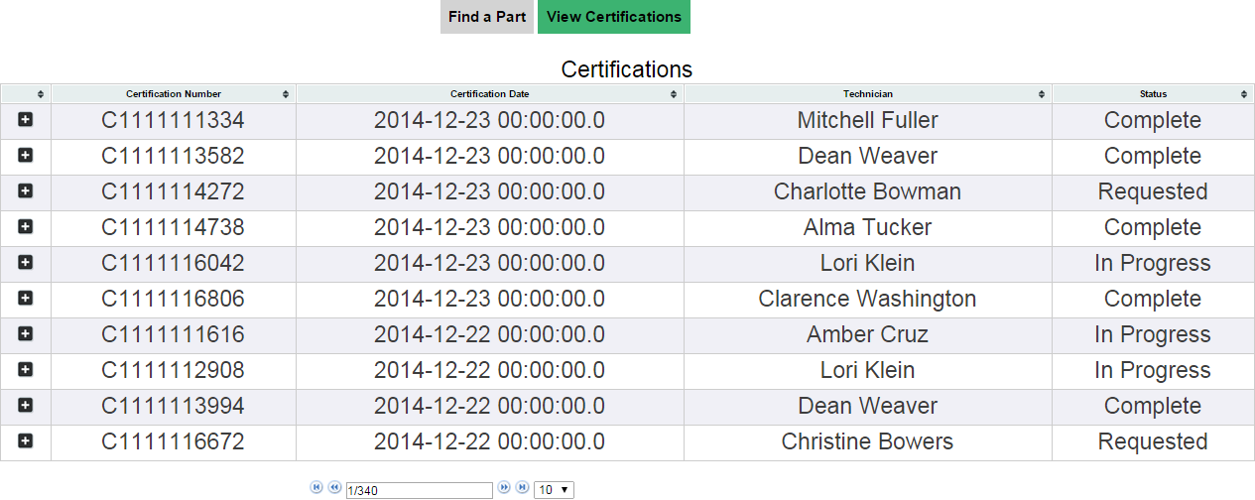

### View all certifications for a specific part number

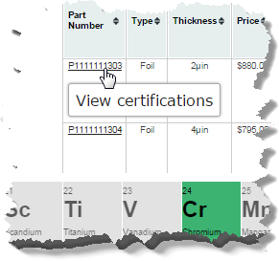

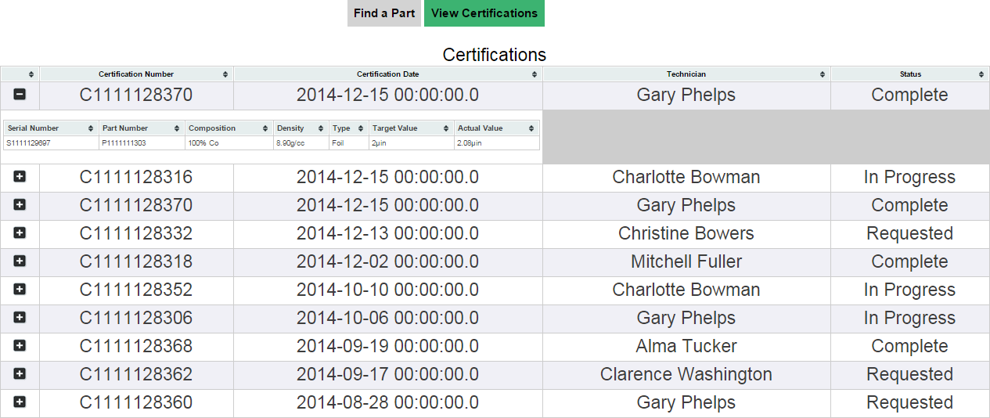

### User modifies a GET variable or some other kind of error occurs

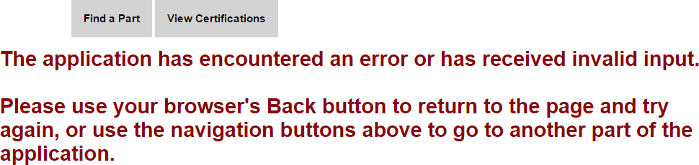

# Data Extract

1. These are standards for which the company is certifying only composition, and not thickness. As I did not implement a front-end means of certifying composition, these are the only elements for which this type of certification is possible.